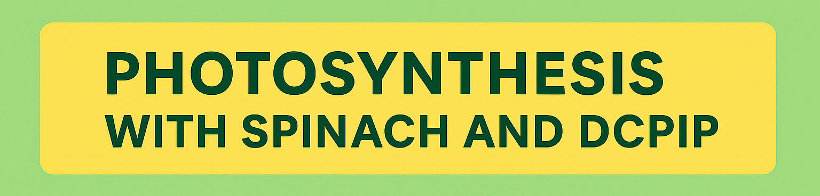

Photosynthesis is how plants make their own food using sunlight. It’s like a recipe where the ingredients are sunlight, water, and carbon dioxide—and the result is sugar (for energy) and oxygen (which we breathe!).
Inside plant cells are tiny green parts called chloroplasts, which act like solar panels. They capture sunlight and use it to power the process of photosynthesis.
But how can we tell if photosynthesis is happening?
That’s where DCPIP comes in. DCPIP is a special blue dye that changes color when it accepts electrons. During photosynthesis, chloroplasts release electrons. If DCPIP is nearby, it grabs those electrons and turns from blue to colorless. This color change is a clear sign that photosynthesis is taking place.
In this experiment, we use spinach leaves to get chloroplasts and mix them with DCPIP. By changing how much spinach we use or how close the light is, we can see how fast the DCPIP changes color. The faster it turns clear, the faster photosynthesis is happening!
This experiment helps us:
- Understand how light and chloroplasts affect photosynthesis
- Practice using scientific equipment
- See real science in action—right before our eyes!

Equipment:

DCPIP Solution 0.07g in 1L water

Buffer Solution

Note: 174g of K2HPO (dibasic) to make up 1L water /

136g of KH2PO4 ( Monobasic) to make up 1L water

Combine the two solutions, about 685mL of monobasic should be added to 315mL of dibasic.

Curvettes with lids x 2

2mL Disposable pipette marked with 2mL

2mL Disposable pipette marked at 1mL

2mL Disposable pipette for spinach

Mortar and pestle

Microscope lamp

25mL measuring cylinder

100mL beakers x 3

10mL measuring cylinder for teachers bench

Chux cloth

Ruler

Timer

METHOD-STUDENT ACTIVITY
Experiment 1: Varying the light intensity
- Collect and label 3 100ml beakers, one with DCPIP, one with buffer and the last one spinach.
- Weigh 2 grams of the spinach leaves, tear into small pieces and place in mortar.
- Measure 20ml of water solution using a 25ml measuring cylinder and add this to the mortar. Grind the plant until a green slurry forms.
- Filter the mixture through a chux cloth into a 100ml beaker.
- Set up the lamp.
- Take a curvette, add 3ml of buffer and 3 drops of spinach liquid. Place a lid on top and invert it (turn it upside down and then right way up). This is your control.
- Place your control 2cm away from your lamp.
- Now take the other curvette and working quickly add 3 drops of spinach liquid, 2ml of DCPIP and 1ml of Buffer. Place a lid on top and invert it notice the colour and line it up with the one at 10cm distance.
- Begin timing until you see both curvette are similar in colour and record this in your table.
- Repeat steps 6 – 9 vary the distance from the lamp eg: 4cm – 30cm.
- Note if the time exceeds 3mins stop the timer and record this time.

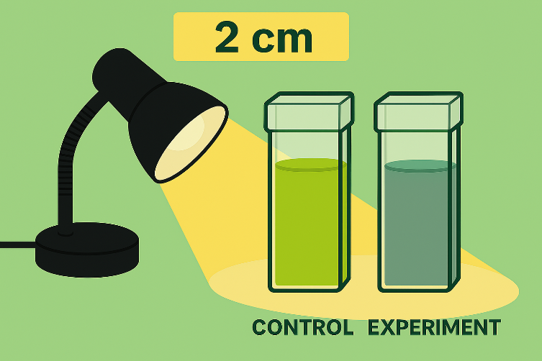

Distance from lamp | Time taken to turn green (mins)

Experiment 2: Varying the concentration of chloroplasts
- Collect and label 3 100ml beakers, one with DCPIP, one with buffer and the last one spinach.
- Weigh 2 grams of the spinach leaves, tear into small pieces and place in mortar.
- Measure 20ml of water solution using a 25ml measuring cylinder and add this to the mortar. Grind the plant until a green slurry forms.
- Filter the mixture through a chux cloth into a 100ml beaker.
- Set up the lamp.
- Take a curvette, add 3ml of buffer and 3 drops of spinach liquid. Place a lid ontop and invert it (turn it upside down and then right way up). This is your control.
- Place your control 10cm away from your lamp.
- Now take the other curvette and working quickly add 1 drop of spinach liquid, 2ml of DCPIP and 1ml of Buffer. Place a lid ontop and invert it notice the colour and line it up with the one at 10cm distance.
- Begin timing until you see both curvette are similar in colour and record this in your table.
- Repeat steps 6 – 9 vary the amount of drops of spinach used eg: 2 -5 drops.
- Note if the time exceeds 3mins stop the timer and record this time.

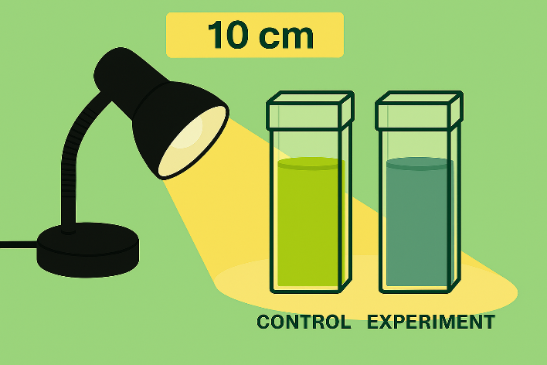

Number of drops of spinach | Time taken to turn green (mins)

